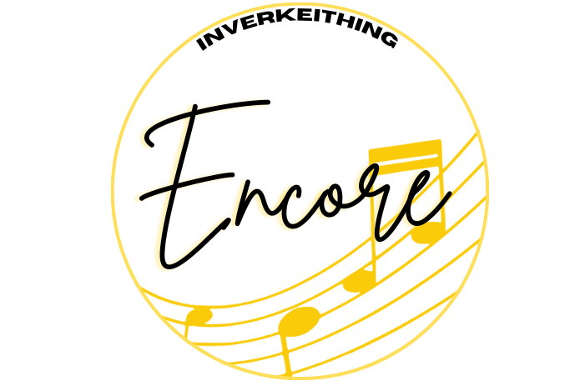
Inverkeithing Encore Harassment and Discrimination
Policy
Inverkeithing Encore is committed to providing a safe, inclusive, and respectful environment for all members, volunteers, and participants. This policy aims to prevent and address harassment and discrimination within the organisation, ensuring that everyone is treated with dignity and respect.
Scope:
This policy applies to all members, volunteers, participants, and anyone involved in the activities of Inverkeithing Encore, including rehearsals, performances, meetings, and events.
Definitions:
- Harassment: Unwanted conduct related to a relevant protected characteristic that has the purpose of effect of violating a person’s dignity or creating an intimidating, hostile, degrading, humiliating, or offensive environment. This includes, but is not limited to:
- Verbal harassment (e.g., jokes, insults, threats)
- Physical harassment (e.g., unwanted touching, assault)
- Visual harassment (e.g., displaying offensive images or gestures)
- Online harassment (e.g., cyberbullying, offensive emails, or messages)
Discrimination: Treating someone unfavourably because of protected characteristic. Protected characteristics include age, disability, gender reassignment, marriage and civil partnership, pregnancy and maternity, race, religion or belief, sex, and sexual orientation.
Policy:
- Zero Tolerance:
- Inverkeithing Encore has a zero-tolerance policy towards harassment and discrimination. Any form of harassment or discrimination is unacceptable and will not be tolerated.
- Reporting:
- Individuals who believe they have been subjected to harassment or discrimination, or who have witnessed such behaviour, are encouraged to report the incident as soon as possible.
- Details on the reporting procedure are available within the welcome handbook.
- Reports can be made directly to a board member or designated volunteer responsible for handling complaints.
- All reports will be taken seriously and treated with confidentiality to the extent possible.

- Investigation
- Upon receiving a report of harassment or discrimination, Inverkeithing Encore will promptly conduct a thorough and impartial investigation.
- The investigation will involve interview with the complainant, the accused, and any witnesses.
- The findings of the investigation will be documented, and appropriate action will be taken based on the evidence.
- Action
- If the investigation finds that harassment or discrimination has occurred, Inverkeithing Encore will take immediate and appropriate corrective action.
- Actions may include, but are not limited to, warnings, mandatory training, suspension, or termination of membership.
- Retaliation against individuals who report harassment or discrimination or participate in an investigation is strictly prohibited and will be subject to disciplinary action.
- Support
- Inverkeithing Encore is committed to supporting individuals who have experienced harassment or discrimination.
- Support may include counselling services, mediation, and other resources needed.
- Awareness
- Inverkeithing Encore will provide regular awareness programs for all members, volunteers, and participants to promote understanding of harassment and discrimination and to ensure compliance to this policy.
Review:
This policy will be review annually by the board to ensure its effectiveness and compliance with current laws and best practices.

