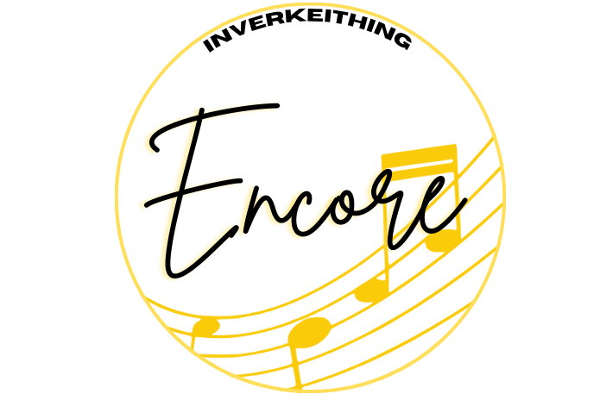
Inverkeithing Encore GDPR and Documentation Retention Policy
During members time with Inverkeithing Encore, we will be working towards putting on productions for the local community. We respect the privacy of our volunteers and members and are committed to protecting their personal data. This policy outlines how Inverkeithing Encore collect, use, store, and retain members and volunteers’ personal information in compliance with the General Data Protection Regulation (GDPR).

- Personal Information Collected

- Inverkeithing Encore may collect and process the following types of personal data:
- Name
- Address
- Email Address
- Phone Number
- Date of Birth
- Information about any medical conditions, disabilities, and /or allergies.
- The contact details of their parents / guardians, any other emergency contact, and details of the person collecting members after rehearsals / shows (including their name, email address, and contact number)
- Member’s & Volunteer’s photograph’s
- Any other information provided voluntarily.

- Purpose of Data Processing:

- Personal data may be used for the following purposes:

  - Membership management
  - Communication

- Consent

- A GDPR consent form has been created and issued to members and volunteers on their joining of the group. By signing the form, they agree to the collection, processing, and storage of their personal data as described above. Members and volunteers have the right to withdraw their consent at any time by emailing info@inverkeithingencore.com .

- Data Security

  - Inverkeithing Encore are committed to ensuring the security of personal data. All reasonable precautions will be taken to prevent the loss, misuse, or alternation of any personal information.

- Data Sharing

- Member and volunteer personal data will not be shared with third parties.

- Data Retention

- Inverkeithing Encore will retain member’s and volunteer’s information for as long as necessary to fulfil the purposes outlined in this policy or as long as required by law. Specific retention periods are as follows:

    - Personal data related to membership: Retained for duration of membership and for up to three years after membership ends.
    - Medical Information: Retained for the duration of membership and for up to one year after membership ends.
    - Emergency contact details: Retained for the duration of membership.
    - Photographs and Videos: Retained for up to three years.

- Rights of Data Subjects:

  - Individuals have the following rights regarding their personal data:
    - Right to access: The right to request access to personal data held by Inverkeithing Encore.
    - Right to Rectification: The right to request corrections to any inaccuracies in personal data.
    - Right to Erasure: The right to request the deletion of personal data under certain circumstances.
    - Right to restrict processing: The right to request restrictions on the processing of personal data under certain circumstances.
    - Right to Portability: The right to request a copy of personal data in commonly used, machine-readable format.

- Videography and Photography:

  - Videos and/or posters will be retained by Inverkeithing Encore for a period of three years. Once publication exists on the internet, it cannot be controlled. Inverkeithing Encore can only control files it manages.

- Contact Information:

For any questions or concerns about data processing practices or to exercise rights under GDPR, individuals are encouraged to contact Inverkeithing Encore via email to info@inverkeithingencore.com

